CỤC ĐỊA CHẤT VIỆT NAM
GENERAL DEPARTMENT OF GEOLOGY OF VIET NAM
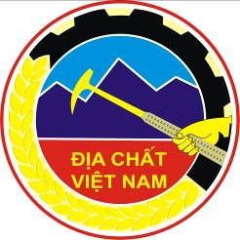

BÁO CÁO THƯỜNG NIÊN
ĐỊA CHẤT 2022
2022 ANNUAL REPORT OF GEOLOGY

MENU

INTRODUCTION 2
I. INSTITUTIONS AND LEGAL DOCUMENTS FORMULATION 3
II. BASIC GEOLOGICAL INVESTIGATION OF MINERALS 4
II.1. Project results completed 4
II.2. Results of implementation of ongoing projects 9
III. STATE MANAGEMENT OF MINERALS 13
III.1. Appraisal and licensing of mineral activities 13
III.2. Inspection and examination work 14
III.3. Economic geology of minerals 16
IV. RESULTS OF INTERNATIONAL COOPERATION ACTIVITIES 18
IV.1. Bilateral cooperation 18
IV.2. Multilateral cooperation 19
V. GEOLOGY SERVES THE COMMUNITY 21

INTRODUCTION
The year of 2022 is a banner year of the implementation of the 13th Party Congress Resolution, including the 5-year socio-economic Development Plan 2021 - 2025, the 10-year socio-economic Development Strategy 2021 - 2030, vision toward 2045, to the geology and minerals sector, the year of 2022 is a great turning point when on February 10, 2022, the Political Bureau issued the Resolution No. 10-NQ/TW on the strategic orientation for geology, mineral and mining industry through 2030, with a vision toward 2045. In the same year, the Government issued Resolution No. 88/NQ-CP dated July 22, 2022, on the Government's action plan to implement Resolution No. 10-NQ/TW.
As the world situation continues to develop in a complicated manner, domestic epidemics, natural disasters, storms and floods cause many obstacles and damage to production and life. Coping with such difficulties and challenges, the General Department of Geology and Minerals of Vietnam has always strived to maintain stability and achieve results in many fields including formulating legal documents, licensing exploration, mineral exploitation, inspection - examination of mineral exploitation and processing activities, collection of royalties, auction of mineral exploitation rights. The basic geological investigation of minerals also achieved significant results. Along with that, international cooperation activities in geological investigation and scientific research were also maintained efficiently and accomplished effective results.
With the leadership and direction of the Party, the Government, the Ministry of Natural Resources and Environment and the joint efforts and consensus of officials, civil servants, public employees and workers of the entire General Department, the General Department's leadership has focused on directing units to drastically, centrally, flexibly and creatively implement assigned political tasks to emulate achievements, celebrating the 20th anniversary of the establishment of the Ministry of Natural Resources and Environment (August 5, 2002 - August 5, 2022).
The Vietnam Geological Department would like to respectfully introduce the main operational results of the General Department of Geology and Minerals of Vietnam in 2022.
DEPARTMENT OF GEOLOGY
OF VIETNAM

I. INSTITUTIONS AND LEGAL DOCUMENTS FORMULATION
After 13 years of implementing the Mineral Resources Law (passed by the 12th National Assembly on November 17, 2010, effective from July 1, 2011), up to now there have been many shortcomings and limitations. Many provisions of the Law have revealed inadequacies, are no longer suitable for practice, and are difficult to implement; many laws related to geology and minerals have been amended, supplemented and promulgated. Implementing the Resolution No. 126/NQ-CP dated September 27, 2022, the General Department has completed the process of formulating documents for the Law on Geology and Minerals. In addition to general regulations, the draft proposes specific regulations on protecting geological resources and unexploited minerals; geological and mineral strategies and planning; basic geological and mineral investigations; mineral areas and mineral management in the national mineral resource reserve area.
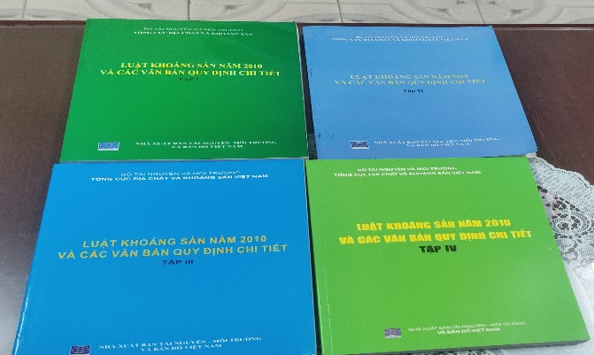
Figure: The system of legal documents on geology and mineral is increasingly complete
On February 10, 2022, the Political Bureau issued Resolution No. 10-NQ/TW on the strategic orientation for geology, mineral and mining industry through 2030, with a vision toward 2045.
The Government issued Resolution No. 88/NQ-CP dated July 22, 2022, on the Government's action plan to implement Resolution No. 10-NQ/TW on on the strategic orientation for geology, mineral and mining industry through 2030, with a vision toward 2045.
The General Department has also completed the development of the Action Plan of the Party Committee of the Ministry of Natural Resources and Environment to implement Resolution No. 10/NQ-TW dated February 10, 2022 of the Political Bureau on strategic orientation for geology, minerals and mining industry through 2030, with a vision toward 2045 and Resolution No. 88/NQ-CP dated July 22, 2022 of the Government on promulgating the Government's action plan to implement Resolution No. 10-NQ /TW February 10, 2022 of the Political Bureau on strategic orientation of geology, minerals and mining industry to 2030, vision toward 2045.
In 2022, the General Department has also completed documents for the Ministry to submit to the Government for the task of Establishing a basic geological investigation plan for minerals in the period 2021 - 2030, vision toward 2050; develop the Geology, Minerals and Mining Industry Strategy to 2030, vision toward 2045; task of Delineating national mineral reserve areas.
In 2022, the General Department complete and submit to the Ministry to sign Circular No. 19/2022/TT-BTNMT dated December 19, 2022 promulgating economic and technical norms for geophysical work. Complete the development of 06 draft Circulars for promulgation in 2023.
In addition, the General Department has advised and submitted to the Ministry of Natural Resources and Environment to issue Official Dispatch No. 1411/BTNTM-ĐCKS dated March 18, 2022, on instructions for exploiting minerals as common construction materials to serve the East side of North-South expressway road construction project for the period 2021-2025 and Official Dispatch No. 6172/BTNMT-ĐCKS dated October 17, 2022, on mineral exploitation as common construction materials to serve assigned projects has been authorized by the National Assembly to apply a special mechanism.
In addition, 17 National Technical Standards (TCVN) on geology and minerals drafted by the General Department have been issued by the Ministry of Science and Technology.

II. BASIC GEOLOGICAL INVESTIGATION OF MINERALS
In 2022, the General Department continues to implement 04 Government projects, of which 01 project is completed and prepares a summary report:

II.1. Project results completed
1. Airborne magnetic-gravity project at scale 1:250,000 of Vietnam's seas and islands: The project "Airborne magnetic-gravity at scale 1:250,000 of Vietnam's seas and islands" has been implemented by the Geophysics Federation under the Vietnam General Department of Geology and Minerals from 2016 to 2022.
In 2022, the Division carry out the airborne magnetic and gravity measurement over an area of 41,487 km2 in the northern waters of the Gulf of Tonkin and the Gulf of Tonkin and accompanying work. New magnetic and gravity data measured and collected by the project have shed light on the morphological factors, continuity and depth of activity etc. of major fault systems on the continental shelf and In the exclusive economic zone of Vietnam, these fault systems have not been clearly identified on seismic data: For example, the Song Lo fault system at the intersection of the Song Hong basin with the Beibuwan basin) and the South Hainan basin (Qiongdongnan) and the extension of the Tuy Hoa shear zone out to sea etc. Additional information on sedimentary premise, structure, magma, depth etc. supporting to the prospection assessment of oil and gas, flammable ice and seabed solid minerals throughout Vietnam's territorial waters and exclusive economic zones. As a result, the resulting maps include the normal magnetic field map, geological structure map, mineral prospect map, deep crust structure map from airborne measurements, documents collected over an area of 616,000 km2 and a final report of the project. The project's final report has been accepted at the grassroots and management levels, and the project's completed workload is in accordance with the assigned plan.
1.1. Project achievements:
- Purchased a new and modern aeronautical geophysical equipment system, received transfer and mastered new technology, thereby improving the professional qualifications of the technical staff to perform their tasks of the Project in particular and of geophysical sector in general.
- Completing the volume of work items of airborne magnetic and gravity survey at a scale of 1:250,000 with an area of 268,768 km2 in Vietnam's seas and islands, the quality ensures the project's requirements. This document source is the one of magnetic and gravity measurement data serving national defense and security and serving the construction of geoid surfaces in the territory of Vietnam. At the same time, through research results, it contributes to affirming national sovereignty in the East Sea.
- Airborne magnetic-gravimetric survey have established result maps for an area of 268,768 km2 including: (1) Magnetic anomaly graph map along the route established on the actual flight route map at scale of 1: 250,000; (2) T₂₀₁₈ magnetic field isochrone map was established at a scale of 1: 250,000 with the isolines cross-section of 10nT (in small areas where the magnetic field changes strongly, the isolines are 50÷100nT); (3) The ΔTa magnetic anomaly field contour map is established at a scale of 1: 250,000 with a cross section of the contour lines of 10nT (in small areas where the magnetic field changes strongly, the contour lines are 50 ÷100nT); (4) The Fai gravity anomaly field map at scale 1:250,000 was established with an isoline cross section of 2 mgal and (5) Bughe gravity anomaly field map at scale 1:250,000 was established with isolines cross section of 2 mgal. These are the main and most important products that the Project has achieved and are important sources of documents serving current and future basic investigation and research.
- The project has collected a large amount of geological, geophysical and other related documents available on the East Sea up to the present time (of which 347,232 km2 is not within the measured area. The project has connected magnetic and gravity fields from sources: on land, implemented by the Project and collected from different sources into a unified map set. Of which the upper part of the East Sea has an area of 616,000 km2. Documents collected during the airborne survey over an area of 268,768 km2 of Vietnam's seas and islands, along with collected documents and results of processing, analysis, and interpretation of documents within the scope of the Project establishing a quite abundant database that could be further exploited for other investigation and research tasks on natural conditions, resources and environment in Vietnam's seas.
- The establishment of geological structure maps based on geophysical data, zoning diagrams to forecast mineral prospects, and deep Earth crust structure diagrams at the scale of 1:250,000 over an area of 616,000 km2 (including airborne magnetic and gravity survey area of 268,768 km2) are resulted from the geophysical data collection, synthetization, processing and analyzing. Specifically:
+ Geophysical document based geological structure map at 1:250,000 scale:
*) Identified the fault system throughout the study area including: 21 deep faults through the crust (F1), 171 deep faults in the crust (F2) and a system of shallow faults (F3). With the project's airborne survey measurement data, combining with land-based data allows determining the continuity of faults from land to sea.
*) The geological structure has been partitioned according to geophysical documents in the study area into structural units, which are 8 Tertiary sedimentary basins with oil and gas prospects: Gulf of Tonkin basin, Song Hong basin, Hoang Sa basin, Phu Khanh basin, Cuu Long basin, Nam Con Son basin, Malay - Tho Chu basin, Tu Chinh - Vung May basin; 13 structural zones include: North Gulf of Tonkin, Thanh Hoa Shelf Zone, Nghe Tinh Shelf Zone, Quang Binh - Da Nang Shelf Zone, Tri Ton Uplift Zone, Khanh Hoa Uplift Zone, Dinh Trung transitional sagging rift zone , Con Son - Hon Hai uplift zone, Cam Ranh - Vung Tau shelf zone, Ca Mau shelf zone, Tay Nam Bo sea zone, Huyen Tran zone.
*) Identified 220 geophysical anomalies related to hidden magma blocks, of which: 92 high density magma blocks, 81 low density magma blocks and 47 magma blocks related to the magnetic field. Delineated and described in detail 14 characteristic magnetic and gravity anomalies that may be related to hidden magmatic intrusions with the premise of discovering related minerals.
+ Zoning diagram for mineral prospect forecasting
The interpretation of magnetic - gravity data and other data sources have identified the prospects of a number of main types of marine minerals, prominent in the study area including oil and gas, flammable ice, coal and hidden magmatic bodies (including underground volcanoes and hidden intrusive bodies) are potentially associated with polymetallic Fe-Mn nodules/crusts and deep hidden solid mineral deposits.
Airborne magnetic and gravity documents combined with satellite magnetic and gravity, sea surface and other geological and geophysical documents have shown the effectiveness of a combination of methods, especially the magnetic-gravity method in the assessment and delineation of marine mineral prospects on a regional scale and large area.
+ Diagram of the deep structure of the earth's crust at scale 1:250,000
The deep structure diagram of the Earth's crust established in the study area fully reflects the three structural units of the Earth's crust including: continental crust, transitional crust and oceanic crust. Identifying deep faults, formulating Moho, Conrad surfaces, crystallization basement surfaces, and crust thickness. Based on the crustal structure characteristics, the deep structure diagram of the Earth's crust has divided 6 crustal regions, including: The truly continental crust region, with crystallization crust thickness > 25 km; The stretched continental crust region, with a crystallization crust thickness of 20-25 km; The strong stretched continental crust, with a concretionary crust thickness of 15-20 km; The basement-beveled continental crust region, with a crystallization crust thickness of 10-15 km, and the ultrathin crust region (transitional crust), with a crystallization crust thickness of 6-10 km.
- The professional results achieved in the Summary Report are highly reliable, providing useful and important information about the characteristics of the magnetic field, gravity field, geological structure and minerals in coastal areas of the project scope, contributing to creating a guiding premise for the basic investigation of resources and environment to serve the development of Vietnam's marine economy in the next period.
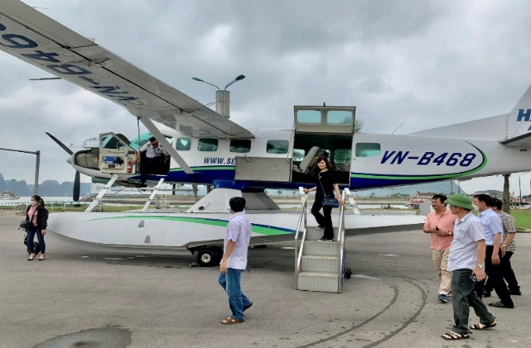
Figure: Field examination of the airborne magnetic-gravity project at scale 1:250,000 of Vietnam's seas and islands project.
2. In 2022, there are 06 component projects under the Northwest project completed, the implementation results are as follows:
The airborne magnetic, gamma spectrum and gravity survey project in some areas of the Northwest region implemented by INTERGEO Division: Airborne magnetic-gravity survey at scale of 1: 200,000 on an area of 9,720 km2 in Bao Lac - Lao Cai - Yen Bai has delineated 17 mineral prospect prediction zones. The airborne magnetic, gamma spectrum survey at scale 1: 25,000 over an area of 550 km2 in Mai Son - Son La region has delineated 8 mineral prospect prediction zones.
Project on geological mineral mapping at 1:50,000 scale in Hoang Su Phi sheet group implemented by the Northern Geological Mapping Division: Discovering and registering 31 mineralization points, mineral manifestations, mineral deposits (discovered 19) including Metals (wolfram, lead-zinc, gold, rare earth); industrial minerals (feldspar, kaolin, mica; quartz, tourmaline, disthene); construction materials (granite tiles; construction limestone; construction sand, gravel) and hot water - minerals. Nam Khoa kaolin and feldspar site: 8 feldspar ore bodies. 333+334a grade resource 890,000 tons. - Nam Phang kaolin, feldspar (mica) site: 13 mineral bodies. 334a grade feldspar resources are 819,023 tons and kaolin resources are 59,100 tons. Results of investigation of Tan Tien quartz site: 12 ore bodies. 333+334a grade resource is 1,373,618 tons.
Project on geological mineral mapping at 1:50,000 scale in Muong Nhe sheet group implemented by the Northern Geological Mapping Division: Registering 15 mineral resource and mineralization manifestations points (07 new minerals manifestation points were discovered). Polymetallic mineral site (Pb, Zn) Na Ho (Mu Ca, Muong Te district, Lai Chau) has 334a resources: 2,910 tons (Pb+Zn), 180 tons of Cu (small scale, little prospect). Pb-Zn mineral site (Ba) Coong Kha (Muong Te district, Lai Chau) has 334a resource: 2,852 tons (Pb + Zn) (small scale). Hang Don Fine Art Stone (Muong Te, Lai Chau): stone transformed from basalt, small scale but has landscape and geomorphological value. Tan Bien facing stone: good quality, large scale.
Project on investigation and evaluation of industrial minerals in the provinces of Nghe An, Thanh Hoa and Hoa Binh implemented by the North Central Geological Division: Evaluated and calculated resources for 9 zones with 3 types of minerals Industrial substances: - Carbonate stone for industrial lime production in 04 areas: Lac Luong (Hoa Binh), Tan Truong (Thanh Hoa), Cam Muoi and Muong Long (Nghe An);
- Silica limestone for facing and fine arts: 01 area is Chau Loc - Tho Loc (Nghe An);
- Quartz includes 02 areas: Quang Phong and Thanh Huong (Nghe An).
- Talc: includes 02 areas: Giap Dat and Tan Minh (Hoa Binh)
Project on investigation and evaluation of industrial minerals in the Northeast Provinces of the Red River Fault implemented by the Northeast Geological Division: Evaluated and calculated resources for 13 zones with 5 types of industrial minerals: - Kaolin - feldspar (ceramic raw materials): 01 Thanh Long area (Tuyen Quang); - Carbonate stone for industrial lime production in 02 zones, Minh Tien (Lang Son) and Hong Quang (Cao Bang); - Quartzite in 02 zones, Xuan Quang (Tuyen Quang) and Bao Nhai – Dien Quan (Lao Cai); - Quartz includes 8 zones: Phan Thanh - Thanh Cong (Cao Bang); Duc Van - Van Tung - Coc Dan, Thuan Mang, Na Khoang, Bang Thanh, Na Chim (Bac Kan); Ban Man (Tuyen Quang); Ban Lien (Lao Cai).
Project om investigation and evaluation of tin - tungsten ore and associated minerals in the southwest areas of the Red River fault implemented by INTERGEO Division: - Three areas have been evaluated: Ban Nga, Ta Lao, Ban Phat (belongs to Tan Xuan area, Van Ho district, Son La province) in which Ban Nga area has tungsten ore, gold and estimated resources, Ta Lao and Ban Phat areas only have signs of mineralization. - Investigated in Dong Van area - Xuan Le (Thuong Xuan district, Thanh Hoa province and Que Phong district, Nghe An province); However, there is little prospect of tin or tungsten ore.

II.2. Results of implementation of ongoing projects
1. "Comprehensive investigation of minerals and completion of the 1:50,000 geological map of the Northwest region to serve sustainable socio-economic development planning":
In 2022, the General Department continue to implement 22 component projects, specifically:
- 06 component projects have completed summary reports (02 projects on 1:50,000 geological mineral mapping, 03 projects on minerals evaluation, 01 project on airborne geophysical measurements);
- 14 projects have basically completed the mineral status assessment and mineral investigation according to assigned plans. Many areas have discovered, delineated and evaluated mineral prospects such as:
+ Ion adsorption rare earth in weathered crust in the right bank of the Red River, in Lao Cai - Yen Bai province;
+ Gold in Nam Khao area, Muong Te district, Lai Chau province;
+ Gold in Thuan Mang - Kim Hy area, Ngan Son district, Bac Kan province;
+ Gold in Ban Tang - Na Quya area, Que Phong district, Nghe An province, copper, gold in Huoi Khon area, Muong Nhe district, Dien Bien province;
+ Coal in Trung Son area, Yen Son district, Tuyen Quang province etc. has identified grade 333 resources in some areas such as gold in Nam Khao area of 1,486kg;
+ Gold from Ban Tang - Na Quya area 1,418kg

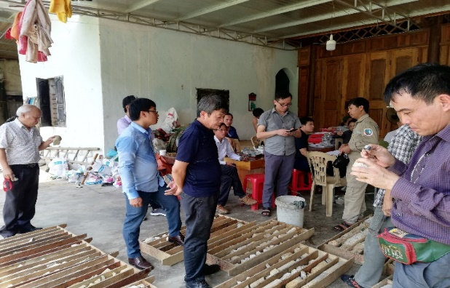
Figure: Field examination on tin - tungsten project in Chau Hong ward, Quy Hop, Nghe An

2. Project "Comprehensive assessment of Mid-Central region's mineral potential to serve socio-economic development":
In 2022, 03 component projects have been implemented; accordingly, implementing the work of assessing the minerals current state, investigating minerals and drilling, excavation and sample analysis; The completed work volume of the projects reached about 100% of the assigned plan. The results have discovered and delineated a number of promising areas of copper ore, gold, quartz minerals, fluorite, quartzite and facing blocks of good quality, qualified to become new mines and delivered to exploration and exploitation stage.
- Component project " Comprehensive assessment of metallic mineral potential in the Mid-Central region": the investigation and synthesis of the status have recorded many original gold mineral sites, including many previously undocumented sites or new discovered placer such as: Sa Binh, Ya Tang, Ya Ly, Mo Rai, Dak To Re, Ia Chim (Kon Tum); Phuoc Loc, Phuoc Kim (Quang Nam), Ea H'Mlay (Dak Lak) etc. The results are an important foundation for implementing further work, in which some areas could be selected for 1:5,000 detail assessment. - Preliminary assessment of 1:25,000 polymetallic copper and gold in Kon Pne area (Gia Lai): basically clarifying the geological characteristics of the assessment area; prospective mineralization zones have been identified, including 1 copper mineralization zone and 1 polymetallic gold mineralization zone. In addition, single polymetallic gold ore bodies were also discovered in the area, which are also very promising. - Preliminary assessment of 1:25,000 gold ore in Bac Po Y area: initially over 10 gold minerals manifestation points were discovered. Gold content of 1.0 - 8.2g/ton. As a result, 3 original gold prospect zones could be delineated for transfer to a detailed assessment of 1:5,000. 2 - Preliminary assessment of 1:25,000 gold ore in Ngoc Do Rlang area: has delineated gold sediment anomalies with high content in the pan sample, signs of original gold mineralization distributed in the Northwest - Southeast structural zone. The results can delineate promising areas for detailed assessment. - Detailed assessment of 1:5,000 copper ore in Kon Nhan and Kon Long areas: continue to carry out geophysical work in 2022; trench, drilling working; All trenching and drilling works are carried out to ensure technical requirements, quality and efficiency; All works encounter copper ore zones. The results contribute to clarifying the geological structure and distribution characteristics of mineral bodies. In addition to the mineral manifestations on the surface, in LK.11drill hole, hidden ore bodies at depths of 99-155m were controlled. Forecasted resources at level 333+334a+334b are currently over 100 thousand tons of metallic copper.

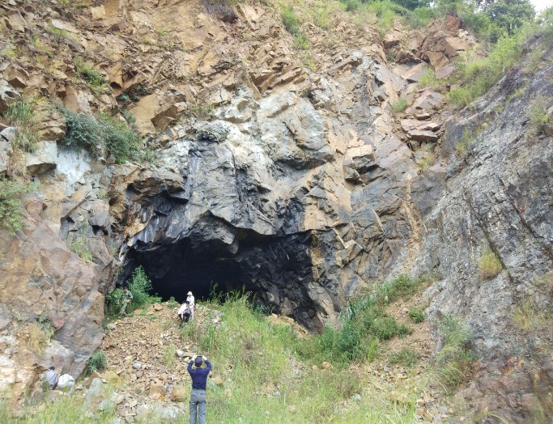

Figure: Field examination on "Comprehensive assessment of Mid-Central region's mineral potential to serve socio-economic development" project

Component project "Comprehensive assessment of industrial mineral potential in the Mid-Central region": Chu Cho Lo area: evaluated 03 fluorite mineral bodies with thickness from 1.0 - 2.9m, CaF2 content reaching from 46.14-77.58%. Delineate and evaluate 11 quartz mineral bodies with a thickness of 2.2-19.7m. Quartz has an average SiO2 content of 97.90%, total iron oxide 0.9%. - Suoi Xem area: 02 original quartz mineral bodies have been delineated and evaluated with an average thickness of 15.1m, extending from 680m - 2,680m; 04 quartz rolling yards with a total area of about 3km2. - An Tuong Tay area: 03 rolled quartz mineral bodies and 02 original quartz mineral bodies have been delineated and evaluated. The original quartz mineral bodies have a thickness of 5.5-17.5m and an average length of 200m. Quartz has an average SiO2 content of 98.23%, total iron oxide content of 0.94%. - Sa Nhon area: 11 quartzite mineral bodies have been delineated with a thickness of 2.1 - 24.5m, an average of 7.0m, the length of the mineral bodies is from 400 - 3,000m extending in the NW - SE direction. Many original mineral bodies, quartz, fluorite, and quartzite have been identified and delineated in the survey and evaluated areas. Evaluate the quality of mineral bodies, delineate resources; Resource results for each mineral type are as follows: Grade (333+334a) quartz is 13,092,179 tons; Grade 333 fluorite is 50,173 tons of CaF2; Grade 334b quartzite is 8,712,594 tons; Delineate 08 areas with an area of 7.03km2 proposed for exploration transfer. Including 06 quartz mineral areas and 02 fluorite mineral areas.
Component project "Comprehensive assessment of the potential of block stone minerals for facing in the Mid-Central region": Summary of current mineral status: Survey of 02 areas of cylindrical basalt and massive basalt in Ia To area, Ia Grai district and Group 1, Kong Chro, Kong Chro district, Gia Lai province have delineated 02 areas to continue mineral assessment at a rate of 1:10,000; Mineral assessment at scale 1:10,000 (no radiation observation): Conducted in the areas of Chu Grun, Co Doc Mountain, Group 1 Kong Chro, Ia Cham, Gia Lai province and Ban Hoong, Phu Yen province. Clarifying geological structure, delineating distribution, morphological characteristics, bedrock exposure, landcover, determining shape, size, fracture weathering zone, fracture systems, fracture types, evaluate the quality of block stone for facing of granite of the Ben Giang-Que Son complex, diorite of the Dinh Quan complex and cylindrical basalt and massive basalt of the Tuc Trung formation. Establish a 1:10,000 geological map, delineate areas with industrial prospects, to evaluate mineral quality and calculate grade 333 resources. Many bodies of intrusive magmatic rock and dense basalt have been delineated, meeting the quality requirements for facing; The results of resource estimation by each type of rock are as follows: grade 333+334a intrusive magmatic rock reaches 19,914,200 m3 of facing stone; grade 333+334a dense basalt is 676,537m3 of facing stone; Delineate 3 areas (1.76km2) of intrusive rock and 3 areas (1.06km2) of dense basalt that are eligible to delivered to exploration and exploitation stage.
3. Project "Investigation and assessment of geological structure and engineering geological characteristics, proposing solutions for exploiting and utilizing territory, serving the construction and development of infrastructure along Vietnam's coastline ”: Completed goals and tasks in 2022 to ensure quality and complete products as ordered. Completed field survey in the key coastal area of Ca Mau peninsula and drilling; The work amount has been completed according to the assigned plan.
The results of the project implementation have clarified the characteristics of topography - geomorphology, geological structure, hydrogeology, and engineering geology of the coastal strip of Vietnam (from Quang Ninh to Kien Giang) at a scale of 1:100,000 for the entire coastal strip of Vietnam (coastal land and shallow coastal sea); at the same time, evaluate the engineering geological characteristics for lithological complexes in the research area and key investigation areas, at a scale of 1:25,000.
With the function of state management of basic geological surveys of minerals and state management of minerals, the General Department has organized and performed tasks well and effectively used capital in basic geological and minerals surveys, mobilizing socialized capital from organizations, individuals, and businesses; Minerals are fully investigated, in accordance with urgent practical needs, contributing to the country's socio-economic development. The management of mineral activities has achieved clear results, overcoming the situation of fragmented and widespread licensing in the locality; Limit environmental pollution in mineral activities. Increase funding sources to contribute to the state budget through calculating fees for royalties, auctioning mineral mining rights, and using data and information on mineral geological documents.
In addition, in 2022, the General Department continues to carry out 12 ministerial-level science and technology projects, of which 06 projects have ended, including: 01 (one) ended in May, 02 (two) ended end of September and 03 (three) projects ending in November (all finished projects have submitted their implementation results to the Ministry of Science and Technology); 06 (six) projects are transferred to 2023. (In 2022, the General Department does not carry out science and technology tasks at the grassroots level).
The projects are carried out seriously and scientifically on the basis of inheriting previous scientific issues, projects have met the set goals and are feasible. As a result, the products of all topics are capable of being applied in practice and have a scientific basis to serve state management and basic geological investigations of minerals; The results of scientific and technological research well serve the tasks of basic geological surveys of minerals at the unit, contributing to completing the contents of the mineral strategy and participating in the task of formulating the basic geological survey on mineral planning in the period 2021 - 2030, vision toward 2050.

III. STATE MANAGEMENT OF MINERALS

III.1. Appraisal and licensing of mineral activities
Licensing for mineral activities is carried out in accordance with the provisions of the Mineral Resources Law and guiding documents and directions of the Prime Minister. The appraisal process when licensing always ensures close coordination and consensus with relevant ministries and provincial People's Committees where minerals are located; ensure the principle that the licensing of mineral activities must be based on mineral planning, be public, transparent, in accordance with the law, in accordance with processing capacity, usage needs and ensure environmental requirements; No new licenses to explore and exploit placer gold; Limit the licensing of fragmented and small mineral exploitation; Do not export raw minerals. In addition, the licensing of mineral activities has been implemented according to the single window mechanism, applying level 3 online public services in receiving and appraising documents.
Under the competence of the Ministry of Natural Resources and Environment
- Receiving, appraising, and returning results of resolving administrative procedures regarding minerals are carried out by the Ministry according to the process of receiving and appraising mineral activity records and mineral mine closure records promulgated in Decision No. 1980. /QD-BTNMT dated October 14, 2021 with forms of receiving and returning results: 1) Level 3 online reception on the national public service portal; 2) Receive directly at the Office of Receiving and Returning results of administrative procedures of the Ministry according to the "single window, interconnected single window” mechanism; 3) Reception by mail and post office. - The appraisal of mineral activity licensing dossiers is guaranteed in accordance with the provisions of the Mineral Resources Law and follows the correct order; The application appraisal process involves close coordination with relevant Ministries, sector and the Provincial People's Committee to ensure that the licensing area is not in an area where mineral activities are banned/temporarily banned and issues related to natural forest land, security and national defense land.
In 2022, the Ministry of Natural Resources and Environment issued 117 Decisions, specifically: (1) signed and issued 24 mineral exploration licenses; (2) signed and issued 39 mineral exploitation licenses; (3) signed and issued 19 Decisions approving the Mineral Mine Closure Project; (4) signed and promulgated 35 decisions on mineral mine closure.
Under the competence of the Provincial People's Committee
According to statistics from local reports, in 2022, the Provincial People's Committee issue new, extend and adjust 503 licenses, including 170 mineral exploration licenses and 333 mining licenses. mineral. In addition, 10 mineral exploitation licenses were revoked, allowed to return 06 mineral exploitation licenses and issued 77 decisions to close mines according to regulations.
Receiving and appraising mineral activity licensing applications ensures quality requirements and compliance with mineral laws. Professional units have closely coordinated, increased exchange and criticism during the appraisal process, ensuring openness and transparency.

III.2. Inspection and examination work
According to the 2022 inspection plan of the Minister of Natural Resources and Environment approved in Decision No. 2507/QD-BTNMT dated December 20, 2021; The 2022 inspection plan was approved by the Ministry of Natural Resources and Environment in Official Dispatch No. 52/BTNMT-TTr dated January 5, 2022. The General Department has carried out inspection and examination work including:
- Inspection tasks:
+ Specialized inspection to determine actual mineral output for some types of minerals in Binh Phuoc province and Nghe An province;
+ Monitor, urge and check the implementation of inspection conclusions in Thai Nguyen, Hai Phong, Dak Lak, Can Tho and Tien Giang provinces.
- Examination tasks:
+ Check the compliance with mineral resources laws in 07 provinces: Bac Kan, Quang Binh, Da Nang, Quang Nam, Binh Dinh, Vinh Long and Dong Nai (integrated with the responsibility inspection chaired by the Ministry Inspectorate ).
+ Examination of mineral exploitation activities and environmental protection in mineral exploitation in 07 provinces: Cao Bang, Thanh Hoa, Hoa Binh, Quang Ngai, Quang Tri, Ninh Thuan and Ba Ria - Vung Tau.
Coordinate with the Ministry Inspectorate to perform the task of inspecting the management, licensing, and exploitation of minerals as common construction materials in Kien Giang and Khanh Hoa provinces under the direction of the Deputy Prime Minister. Le Van Thanh.
- Unscheduled inspections based on complaints, press reports and state management requests for minerals (11 inspections in the Northern provinces and 30 inspections in the Southern provinces).
Common violations: The mineral exploitation license has expired for more than 12 months but the application for mine closure is not submitted to the competent state agency according to regulations; Do not install a weighing station at the place where raw minerals are transported out of the mine to monitor and store related information; Prepare a map of the current state of the mine and cross-section of the area where mineral exploitation is allowed, but the information and data on the map and cross-section are not fully shown according to regulations and are different from the actual current state of mineral exploitation; Prepare statistical reports and inventories of remaining mineral reserves in areas permitted for exploitation without complete information according to the form prescribed by the Ministry of Natural Resources and Environment; Mining minerals with a total area beyond the boundary of the area permitted for surface mining of about 0.3 hectares (exceeding from 0.1 hectares to less than 0.5 hectares); improper exploitation of seam opening system (for open pit mining); incorrect exploitation sequence; incorrect exploitation system; incorrect exploitation time frame.
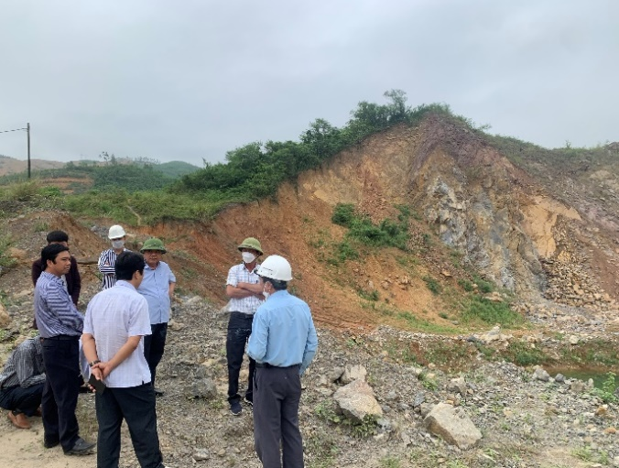
Figure: Officials of the Central Mineral Activities Control Department inspect a stone mine in Cam Lo, Quang Tri

Total number of decisions to sanction administrative violations issued by the General Department: 74 decisions for 72 organizations (increase from 38 organizations in 2021), 64 decisions implemented;
The total amount of fines for administrative violations is 18,521 million VND (higher than in 2021, the fine amount was 2,938 million VND).
In parallel with the thematic inspection, examination, and inspection, examination on the compliance with regulations of the law on mineral resources and other related laws, the Vietnam General Department of Geology and Minerals has focused on the work Check the correction of existing problems and violations that have been pointed out according to the results of previous inspections and tests (often called "post-inspection"). Through "post-inspections", businesses have partly raised their awareness of compliance with the law in general and the law on minerals resources in particular, contributing to restoring order in mineral exploitation in recent times. Faced with the fact that the force in the apparatus of the agency carrying out specialized inspection and examination of minerals is still thin in quantity and uneven in quality, the General Department has focused on combining inspection and examination work. Direct inspection with inspectors, indirect inspection through periodic reporting control combined with pilot application of the Mineral Exploration/Mining Activities Monitoring Book as a basis for handling violations of organizations and individuals engaged in mineral activities. Reality shows that indirect inspection and examination also contribute somewhat to the General Department's overall achievements in inspection and examination work.
Through planned inspections and unscheduled inspections as required by the inspection and examination work, the inspection and examination teams of the Vietnam General Department of Geology and Minerals have detected and handled punish administrative violations according to regulations, contributing to improving the effectiveness and efficiency of state management of minerals; to rectify and bring mineral activities of organizations and individuals into more respectable to restore order in mineral exploration and exploitation activities, improve responsibility and awareness of law compliance of businesses. , contributing to improving the efficiency of production and business activities, ensuring sustainable development requirements

III.3. Economic geology of minerals
III.3.1. The fee calculation of data and information utilization on the results of the State's mineral survey and exploration
In 2022, the Ministry of Natural Resources and Environment issued 12 Decisions approving the results of determining mineral potential assessment costs and mineral exploration costs that must be reimbursed because the state has invested a total amount of 45.113.364.681 VND; collected for the state budget an amount of 83.744.487.619 VND (including the amount approved in 2021); The total amount of money that organizations and individuals engaged in mineral activities that are not yet due or are delayed in repaying money according to approved Decisions is 63.775.765.017 VND; The Ministry has directed specialized agencies to urge and take measures to handle violations (if any) for organizations and individuals who intentionally delay in refunding fees for using approved information and data. .
III.3.2. Estimation of royalties (granting mineral exploitation rights)
In 2022, the Ministry of Natural Resources and Environment issued 62 Decisions approving royalties with a total amount of more than 1.300 billion VND; directed specialized agencies to issue a document requesting local Tax Departments to issue notices of royalties payment for 391 mineral exploitation licenses issued by the Ministry of Natural Resources and Environment with a total amount of money over 2.307 billion VND; Organize inspection of the royalties estimation (period 2014 - 2021) and the determination of mineral potential assessment costs and mineral exploration costs that must be reimbursed due to state investment (for mineral exploitation license valid from March 10, 2018) issued by the Provincial People's Committee in 06 localities including: Khanh Hoa, Ba Ria - Vung Tau, Binh Duong, Quang Nam , Binh Dinh, Lang Son. Inspection results show that the provinces have fully implemented tasks according to the provisions of the law on minerals resources as well as the guidance and direction of the Ministry; synthesize some existing problems and problems of localities to propose amendments and supplements to the draft Decree amending and supplementing Decrees implementing the Mineral Resource Law.
According to data up to the time of reporting, the total amount of royalties approved by localities in 2022 is VND 2.608 billion; The total amount paid to the budget in 2022 is VND 3.773,7 billion.
III.3.3. Auction of mineral exploitation rights
Under the competence of the Ministry of Natural Resources and Environment
In 2022, the Ministry of Natural Resources and Environment successfully organized 02 auctions of mineral exploitation rights for 02 mineral areas including: (1) Marble area in Chau Tien commune, Quy Hop district, Nghe An province with auction winning rate (Rdg) of 1.5%; (2) Granite area in Hon Gio 1 area, Nhon Hai commune, Ninh Hai district, Ninh Thuan province with auction winning rate (Rdg) of 1.3%.
Under the competence of the Provincial People's Committee
According to statistical data up to the time of reporting, in 2022, the Provincial People's Committee has approved 204 mineral mining rights auction areas and successfully organized auctions under its authority, ensuring fairness, open, transparent, and select businesses with sufficient capital, technology, and equipment capacity to participate in mineral activities.
The auction of mineral exploitation rights in some localities shows that the efficiency is not high. Although the People's Committees of the provinces have successfully organized auctions for mineral exploitation areas to use as common construction materials to serve construction needs and leveling materials for traffic works in the province, such as: Phu Tho, Bac Giang, Thanh Hoa, Quang Tri etc. However, they all encounter difficulties in implementing compensation, site clearance and other administrative procedures to put the mine into operation.

IV. RESULTS OF INTERNATIONAL COOPERATION ACTIVITIES

IV.1. Bilateral cooperation
IV.1.1. Cooperation with Korea: In 2022, the General Department meet and work with the delegation of the Korean Embassy in Vietnam and representatives of agencies and businesses in Korea: Exchange and provide information on mineral resources that Korean agencies and businesses are interested in. Propose to the Korean Embassy the contents that need to be discussed to promote cooperation between the two countries in the field of geology and minerals in the future: Cooperation in research, technological innovation, and improved efficiency survey, evaluation and exploration of minerals, including rare earth minerals; Cooperation on geological database development and smart management technology of urban geospatial systems in Vietnam; Carbon dioxide capture and storage system (CCS) research and development program; Cooperate in research and transfer of rare earth processing technology from typical types of mines in Vietnam.
The General Department also meet Commercial attaché Min Moonki - Ministry of Foreign Affairs of Korea to discuss cooperation projects on urban geology; Meeting and working with the Korean delegation on mineral resource exploration and exploitation.
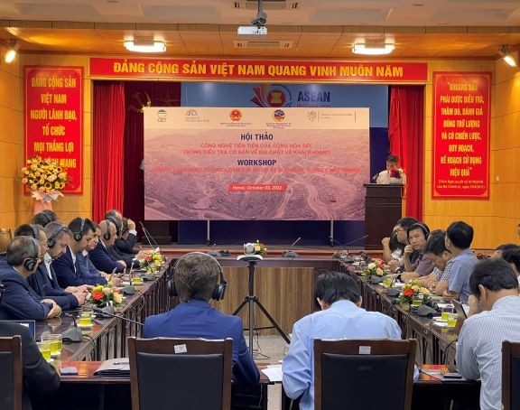
Figure: The workshop focused on cooperation between Czech and Vietnamese businesses in mining technology

IV.1.2. Cooperation with Canada: The General Department worked online with Swanhill Company - Canada to discuss cooperation in the field of geology and minerals.
IV.1.3. Cooperation with the United States of America: The General Department works with the economic counselor, US Embassy in Hanoi on cooperation issues in the field of rare earths and minerals.
IV.1.4. Cooperation with the Czech Republic:
The General Department works with the Economic Counselor of the Embassy of the Czech Republic in Vietnam in the field of rare earths and minerals. In October 2022, the General Department coordinated with the Embassy of the Czech Republic in Vietnam to organize the Workshop "Advanced technology of the Czech Republic in basic survey of geology and mining". Attending the Workshop were businesses operating in units under the Ministry of Natural Resources and Environment; units under the Ministry of Industry and Trade; University of Mining and Geology; University of Natural Sciences, Hanoi National University; Hanoi University of Natural Resources and Environment; Enterprises operating in the field of geology and minerals in the Czech Republic.
The conference is an opportunity for delegates of the two countries to exchange, share experiences and have valuable comments on approaches to sustainable cooperation in mineral exploration and processing technology in Vietnam; At the same time, discuss and introduce advanced technologies of Vietnam and the Czech Republic in mining and mineral processing. In the mining sector, both countries have achieved significant progress in the years before COVID-19, including the conclusion of the Memorandum of Understanding on cooperation between Vietnam and the Czech Republic in field of geological investigation, signed on April 17, 2019 in Prague, Czech Republic.
Main contents discussed at the Conference:
- Exploration technology for complex mining and hidden, deep minerals using geophysical methods - Association of Mining Technology of the Czech Republic
- Introducing the online coal analysis and quality management system
- Integrated electrical systems in modern mining areas
- Technology using high quality steel wire for multiple applications in hidden and deep mineral exploitation
- Systems and solutions for safe mining operations, CO2 reduction methods towards mitigating climate change and environmental pollution
IV.1.5. Cooperation with Australia: The General Department works with the Australian Government Trade and Investment agency - Austrade and Blackstone Minerals Company, Appian Capital Advisory Group on foreign investment policy in Vietnam in the field of mineral processing, metallurgical production.

IV.2. Multilateral cooperation
IV.2.1. ASEAN Cooperation Action Plan on Minerals (AMCAP) III, period 2021-2025: In 2022, the General Department continue to participate in ASEAN cooperation activities on minerals within the framework of AMCAP III, 2021-2025
Attend the 7th ASOMM working group (JWG) online meeting from March 8-10, 2022 to discuss priority actions of the ASEAN cooperation action plan on minerals for the period 2021-2025, specifically can be divided into 04 working groups as follows: (1) 20th Working Group Meeting on Mineral Trade and Investment (WGTIM); (2) 20th Working Group Meeting on Sustainable Mineral Development (WGSMD); (3) 20th Working Group Meeting on Mineral Information and Database (WGMID); (4) 20th Working Group Meeting on Capacity Building Mineral (WGCBM).
+ Submit to the Ministry of Natural Resources and Environment for review and guidance on the contribution to the ASEAN Mineral Trust Fund (AMTF) in 2022 (15,000 USD). Of which, 20% of the contribution support the implementation of activities in the ASEAN Mineral Cooperation Action Plan.
Attend the online meeting of the ASEAN Summit on Minerals group (ASOMM 22) from November 22-25, 2022 organized by host country Brunei Darussalam.
IV.2.2. Committee for Coordinating Geological Programs in East and Southeast Asia (CCOP):
Attend the 78th annual cop board of directors conference in Ulan Bato, Mongolia from May 30 to June 2, 2022. Content: Completing the Geology Action Plan within the framework of CCOP member countries; Provide initiatives to protect geological resources; Discuss geological project activities in the area; Report on CCOP's performance results for the period 2020-2021 and implementation plan for the period 2022-2025.
IV.2.3. International forums and organizations
Attended the ASEAN-China Liaison Conference on urban mineral geology. Exchange and learn experiences in urban geology and mineral geology between ASEAN countries, Mongolia, Japan, China and Korea.
Participate in the IGCP-UNESCO Annual Conference in Paris, France. Purpose: Enhance professional capacity through participating in technical group meetings with Asia-Pacific countries under IGCP-UNESCO with the theme: Cooperation to protect the environment in geological exploration and mineral exploitation; Seeking opportunities for international cooperation, linking with organizations and individuals through working sessions with the Vietnam Permanent Delegation next to UNESCO and working sessions with the Head of the Earth Science Unit - UNESCO.
IV.3. Organization and management of international agreements signed by General Department
In 2022, the General Department continue to implement the signed cooperation agreements: Memorandum of Understanding on cooperation in the field of geology and minerals with the Geological Department of the Czech Republic on discussing and establishing specific activities. possible within the framework of the MOU such as organizing a workshop in Hanoi. Memorandum of understanding on technical cooperation in earth sciences with the UK Natural Environment Research Committee on construction cooperation and coordination in establishing a project on urban construction materials, piloted in Hanoi and coastal disaster projects...
+ Commit to implementing the Ministerial-level agreement on ASEAN cooperation on minerals: ASEAN Cooperation on Minerals Action Plan (AMCAP) III, phase II: 2021-2025.
Implement tasks and solutions of the four ASEAN Working Groups on minerals, contributing to the development of the mineral industry, including improving capacity in mineral investigation, exploration, exploitation and processing; Complete mineral information and data base; Sustainable mineral development and increased trade and investment in minerals in the region, specifically:
+ The implementation status of signed cooperation agreements is as follows:
- Memorandum of understanding on cooperation in the field of geology and minerals with the Czech Geology Department, Czech Republic: discuss and develop specific activities within the framework of the MOU such as organizing a workshop in Hanoi.
- Memorandum of understanding on technical cooperation in earth sciences with the Natural Environment Research Committee, UK: Cooperation in building and coordinating the establishment of a project on urban construction materials, piloted at Hanoi and coastal disaster project.
- Continue to implement cooperation contents in the Memorandum of Understanding on geoscience cooperation with the Geological Department of Denmark and Greenland.
- Continue to implement cooperation activities in the Memorandum of Understanding between the Ministry of Natural Resources and Environment and the Ministry of Natural Resources and Environment of the Russian Federation.
- Participated in the CCOP delegation, the ASEAN - China Mining Cooperation Forum and the delegation under the task of "Operating funds of the Science and Technology subcommittees: ASEAN - COST, Un-GGIM and UNESCO".

V. GEOLOGY SERVES THE COMMUNITY
Geological museum
The Museum of Geology is a specialized museum at the National level, a cultural institution that plays an important role in museum research and geological conservation; Collect, store - preserve, display - propagate - introduce geological and mineral artifacts to serve the needs of research, study, propaganda, education, sightseeing and cultural enjoyment of the community. copper. The Museum of Geology has two permanent exhibition facilities in Hanoi and Ho Chi Minh City. In 2022, nearly 5.000 visitors were welcomed (including nearly 500 foreign visitors); Propagating and distributing more than 1.800 leaflets introducing the museum.
Regarding the service of sightseeing, research and study
In 2022, the Museum register visitors 1.873 times; Explanation of the display for 22 visiting groups; Get opinions from visitors to the geological museum with more than 1.073 visitor reference forms.
Regarding the preservation and display of specimens
The Geology Museum has collected, stored and displayed a fairly large number of samples. In Hanoi, geological samples are displayed in a 3-story building with a total area of 1.200 m² with 4.228 specimens of all kinds. In Ho Chi Minh City, geological specimens are displayed in rooms with a total area of 564 m2 and an outdoor space with 3.400 specimens of all kinds; including rock samples, drill cores, minerals; metallic, non-metallic, rare minerals (gold, gemstones); petroleum and paleontology.

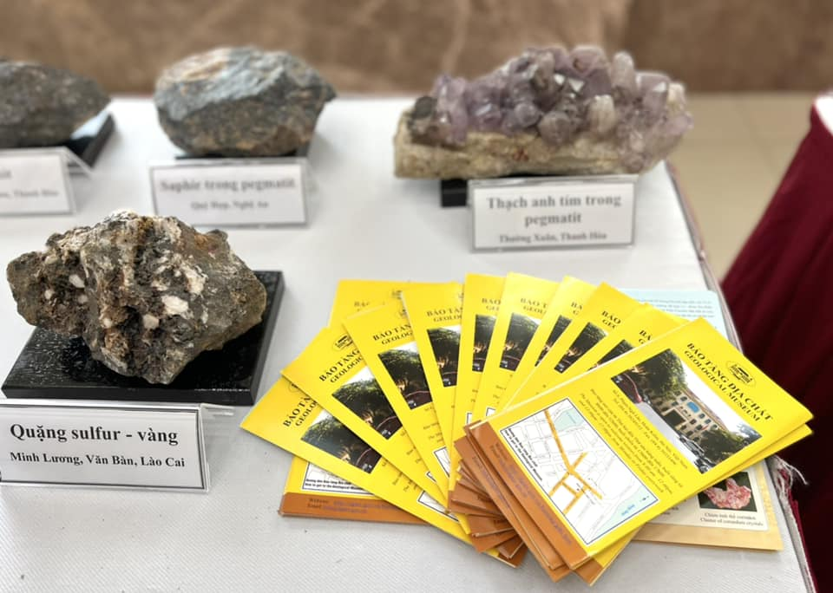
Figure: Displaying samples at the 20th Anniversary of the establishment of the Ministry of Natural Resources and Environment

In 2022, the Museum in Hanoi has tested the information of some cabinets and specimens on display in the form of QR codes for visitors to find out the content themselves. The museum organized a mobile display at the 20th Anniversary of the establishment of the Ministry of Natural Resources and Environment in August 2022 at Hanoi National Convention Center,
In order to promote and introduce to visitors the Geological Museum, in 2022, the Museum distribute propaganda leaflets to introduce the Museum; Distributed 1.800 leaflets, of which: 800 leaflets at Ho Chi Minh City branch; showroom in Hanoi propagated 1.000 flyers.
Preserve display samples in display cabinets and pedestals, protect display cabinets and pedestals, models, and maps; The museum also replaced label specimens in cabinets and display stands, including 230 new label; Use a sample set for practice including 33 sediment, magma, and metamorphic samples for students of schools (Branch);
The museum gallery has recorded 02 scientific video clips, edited 01 scientific video clip "Earth historical development milestones; How to find a meteorite; Science explains solar and lunar eclipses; Ho Chi Minh City Geological Museum branch recorded 01 video clip with scientific content related to earth science.

